

Mohit Maru

C wing flat no C-1001 madhupushpa society,
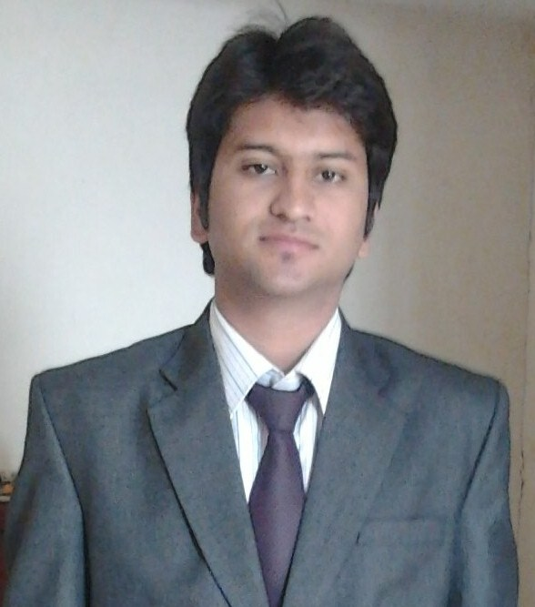
New Pune- Mumbai Highway, wakad link road,
Near Wakad Police Chowki, Pune – 411057
Mobile : 091.9975877968,
E-mail: Mohit.maru@indiraisbs.ac.in

Specialization:
Major: International Business
Minor: International Marketing

Education:

PGDBM Indira School of AICTE 2012-2014 65% Ist Yr
(IB) business Studies, Pune

B.Com St. Wilfred College Rajasthan university 2009-2012 55%
(Pass course) Jaipur

HSC BBS, Bikaner CBSE Board 2008-2009 56%
(Commerce)

SSC RSV, Bikaner CBSE Board 2007 60%

Project Details:

Company: HDFC Bank
Project Title: To understand the Cash management services provided by HDFC bank
and to identify satisfaction level those who are using this service and increase its
customer base.
Duration: 50 Days.

Details:
      - Work under the direction of WBO Manager, Deputy Manager to get the insight knowledge about CMS.
      - Carried out a research to check the customer satisfaction levels those who are using this service.
      - Advised solution to increase and improve the satisfaction level.
      - To discover and identified the future prospect customer of cash management for HDFC bank.
      - Handling all operational work like (Authentication of cheque,
Batch preparation, Collection and authentication of slips)

Achievements:
- Lead generation for bank one for CMS another one is for Gold loan.

Computer Skills:
Operating Systems: Windows (7, 8)
Packages Known: MS Office (Word, PowerPoint, Excel)
Tally

Additional Qualification:

- Successfully completed an intensive programme on 40 hrs Module in export-import management.
- Successfully completed a 250-hour comprehensive performance-based Leadership Development Programme by Stratecent Consulting, and have acquired the following skills:

- Negotiation Skills
- Problem Solving Skills
- Systems Thinking
- SPIN Selling
- Strategy

- Successfully completed an 8 hrs Joint certification program by ICICI securities.
- Successfully completed a certification course in Financial/commercial accountant.

Extra Curricular Activities

- Work for NGO and sale membership forms and join new members, provide interns to local firms of Jaipur.
- Played state level Cricket for Rajasthan cricket association.
- Actively participated in CSR activities of college.
- Got first prize in Rags to riches organised by Aarohan cell.
- Got exposure to International firm in Dubai.

Personal Details:

Date of Birth: 15/07/1991
Marital Status: Single
Strengths:
- Adaptive.
- Positive, Creative.
- Leadership.
- Team player.
- Travelling.
Languages: English, Hindi, Marwari,French(basic)

